Institute of Light Metals (ILM) Joint Usage/Research Grant Report in FY 2025
2026/04/30
Principal investigator |  | Affiliation | Faculty of Engineering Sciences, Kyushu University, Japan
 |  | Job title | Associate Professor
 |  | Name | Abdelrahman Zkria AHMED
Collaborated researcher of ILM |  | Affiliation | Magnesium Research Center
 |  | Job title | Director of Magnesium Research Center
 |  | Name | Yoshihito KAWAMURA
Title of the joint research |  | Advancing Biocompatible Nanodiamond Composite Coatings for Mg-based biodegradable Implants
Joint research Program  ※check the box |  | ■ Program for Joint Usage / Research Centers (JURC)  □ Program for International JURC  □ Program for providing samples and materials  □ Program for using ILM facilities for sample analysis and characterization |  |  | □ Focused themes  □ Transportation  ■ Biomaterials  □ Bridge/building materials  □ Kink strengthening  □ Independent research theme
Name of joint usage apparatus |  | TEM, Hardness, Scratch test, other available apparatus related to the proposal
Total amount of grant | Travel expense（ 240,000 JPY） |  |  | Consumable Fee（ 60,000 JPY）
Research Results
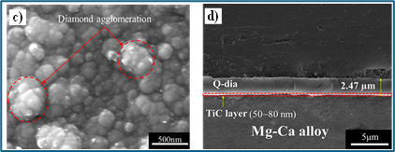
【The major results】
Regardless of the usage of the grant amount, related to the proposed project, the team at Kyushu University developed Quench-produced Diamond (Q-Dia) Coatings on Mg-Ca alloy with the by employing TiC interlayer that provided the best adhesion strength and coating uniformity. Electrochemical analyses demonstrated that Q-dia coatings markedly enhanced the corrosion resistance of Mg-Ca alloy in 3.5 wt% NaCl solution, increasing the corrosion resistance from 0.336 kΩ.cm² to 1.78 kΩ.cm². These findings highlight Q-dia as promising protective coating films for improving the corrosion resistance and durability of magnesium-based alloys.

【Future Prospects】
The future plan aims to expand the application of Quench-produced Diamond (Q-Dia) coatings on different types of Mg-based alloys, such as ZE53, AZ31, for corrosion and wear resistance. Furthermore, antibacterial behavior of Q-Dia coatings on Mg-based alloys will be explored.

【Concrete results】

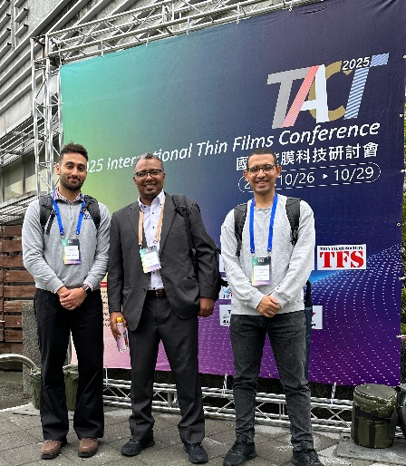
● Publication: A.H.Oraby, H. Chen, H. Lin, T. Yoshitake, A.Z.Ahmed* “Interlayer-assisted growth of quenched-produced diamond coatings on Mg–Ca alloys for improved corrosion resistance in sodium chloride solution” Journal of Alloys and Compounds 1050, (2026)185888

● International Conference: The PI from KU Assoc. Prof. Abdelrahman delivered invited talks, and two students gave oral presentations at Taiwan Association for Coating and Thin Film Technology (TACT-2025) Conference, Taipei, Taiwan (October 26th to 29th).

